Warning – Powertrain Cooling – CGEA1.3

Functional Description

The purpose of the Powertrain Cooling Warning is to provide a visual warning to inform the customer that vehicle performance is reduced once the temperature threshold is exceeded. This feature is part of the GTDI engine Smart Cooling function in the PCM that ensures P/T Cooling protection under severe Trailer Tow and high ambient temperature conditions.

The Powertrain Cooling Warning correlates the Operational mode and the EngMsgTxt_D_Rq signal from the PCM to determine when to display the Powertrain Cooling message center warning.

Interfaces

Interface Context Diagram (I/O Block Diagram)

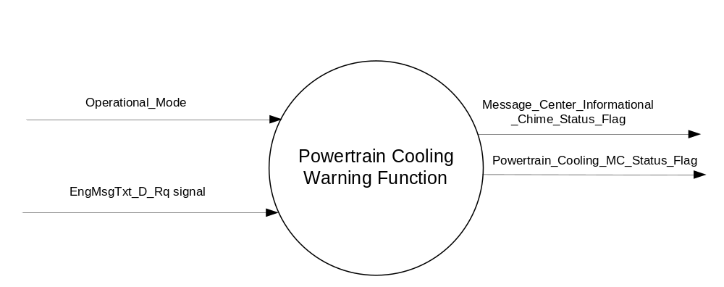
Figure 1 Warning – Powertrain Cooling

Inputs
      - INTERNAL:
    - Operational_Mode
- MUX message from the CAN bus from PCM

- EngMsgTxt_D_Rq Signal
Signal Name | Size (bits) | Detail | Units | Res. | Offset | State Encoded | Min | Max
EngMsgTxt_D_Rq | 2 |  | SED | 1 | 0 |  | 0 (0x0) | 3 (0x3)
 |  | No_Message |  |  |  | 0x0
 |  | Power_Reduced_to_LowerTemp |  |  |  | 0x1
 |  | Undefined_1 |  |  |  | 0x2
 |  | Undefined_2 |  |  |  | 0x3

Output
Powertrain_Cooling_MC_Status_Flag that is used to control the Warning displayed in the message center.
Message_Center_Informational_Chime_Status_Flag

Function/Performance

Operational Modes

Mode | Differentiating Vehicle Conditions
Sleep Mode | Powertrain_Cooling_MC_Status_Flag = Inactive
Limited Mode | Powertrain_Cooling_MC_Status_Flag = Inactive
Normal Mode | Powertrain_Cooling_MC_Status_Flag = Inactive/Active
Crank Mode | Powertrain_Cooling_MC_Status_Flag = Inactive/Active

The above table references the setting of the Warning flag as per this section. However, the actual warning display operational modes are displayed in the Message Center section of this SPSS.

Voltage Levels

Refer to the Cluster Features Table located in the Operational Modes and Voltage Range Strategies Section of this SPSS

Human-Machine Interface

Visual

1.3.3.1.1 Indicator Graphics / Display Format
Message Center Text Warning Message as defined in section 1.3.5.7 of this document.

1.3.3.1.2 Indicator Color Coordinates

Reference section COLOR & ILLUMINATION REQUIREMENTS (GRAPHICS).

Audio

See Table 1.2

Switch Control Logic

None.

System Accuracy

Within 100 msec of receiving a message that results in a change of state the cluster will update the output flag to the proper state.

Operation: Performance and Functional

Subsystem Algorithm Flowchart / State Diagram

- State Matrix for Powertrain Cooling Warning
Operational_Mode | EngMsgTxt_D_Rq  Signal | Powertrain_Cooling_MC_Status_Flag
Normal or Crank | On (0x1) | Active
All Other Cases |  | Inactive

Table 1.2 MC Warning ID to Chime Status Flag
MC Warning ID | Active Chime_Status_Flag
W712 | Message_Center_Informational_  Chime_Status_Flag

Operation Description (supports algorithm flowchart /state diagram)

- When Powertrain_Cooling_MC_Status_Flag = ACTIVE, Warning ID W712 will be ACTIVE.
- For definition of how the Message Center arbitrates and displays Active warnings, see the Warning / Alert Display Logic Diagram, located in the Message Center – X Display with W Button Interface section of this SPSS (where X and W are appropriate values in this document).

Function Safety Classification (EMC)

Class B

Memory Storage
Parameter Name | Description | Value at  Battery Connect | Value at  Module Wake-up
Powertrain_Cooling_MC_Status_Flag | State Variable used by M/C Warning Arbitrator | Inactive (0x0) | Inactive (0x0)
EngMsgTxt_D_Rq Signal | Input CAN Signal sent from the PCM. | 0x0 (No_Message) | 0x0 (No_Message)
Operational_Mode | 4 state indicator for cluster operational mode | Limited | Limited or Normal or Crank
Message_Center_Informational_  Chime_Status_Flag | Used to control the state of the chime to the Chime Arbitrator | Inactive | Inactive

Prove Out

No.

Reconfigurable Telltale

No.

Message Center Msg

Warning Message ID W712 as defined in the Text Message List section of this SPSS.

Error Handling

Missing Message Strategy

This signal may not be supported on all PCM/ECM's on a given program, and a missing message results in no action. Thus, no DTCs are specified for the Powertrain Cooling Warning.

Diagnostics

Self Test

None

Engineering Test Mode

Not Applicable

Part II Performance

Supported Diagnostic Trouble Codes (DTCs)
DTC | Description | When Logged

Reference Specification

IS-0001 WARNINGS/INDICATORS/DISPLAYS PROVEOUT
IS-0052 OPERATING VOLTAGES - FUNCTIONAL/PERFORMANCE
IS-0069 FUNCTIONAL IMPORTANCE CLASS
IS-0324 WINDSHIELD & OTHER REFLECTIONS
IS-0327 WARNING INDICATOR EVALUATION
IS-0379 NORTH AMERICAN WARNINGS AND INDICATORS STRATEGY

IL-0017 TELLTALE AND INTERIOR ILLUMINATION – COLOR AND INTENSITY
IL-0019 GENERAL ILLUMINATION DIMMING
IL-0021 CRAFTSMANSHIP – DISPLAYS
IL-0022 GENERAL ILLUMINTATION COLOR
IL-0023 CLARITY/LEGIBILITY/READABILITY/VISUAL CONTRAST
IL -0043 OPERATIONAL ENVIRONMENT FUNCTIONALITY
IL -0045 COLOR
IL -0047 TELLTALE, INDICATOR AND DISPLAY LIGHT INTENSITY
IL -0048 ILLUMINATION ACCEPTABILITY

03-0661 PLACEMENT: CONTROL AND DISPLAY LOCATIONS
03-0662 PLACEMENT: LOGICAL GROUPING FUNCTION AND USAGE
03-0664 PLACEMENT: DOWN VISION TO COMPONENTS WITH HIGH VISUAL DEMAND
03-0665 PLACEMENT: EXPECTED LOCATIONS OF CONTROLS AND DISPLAYS VDS
03-0670 INTERIOR VISIBILITY
03-0671 INTERIOR VISIBILITY: REFLECTIONS FROM COMPONENTS & SURFACES
03-0672 INTERIOR VISIBILITY: REFLECTIONS IN DISPLAYS
03-0673 INTERIOR VISIBILITY: VISUAL OBSCURATIONS
03-0674 INTERIOR VISIBILITY: ILLUMINATION CONTROLS / DISPLAYS
03-0675 INTERIOR VISIBILITY: VEILING GLARE
03-0677 INTERIOR VISIBILITY: SUNLIGHT WASHOUT
03-0681 IDENTIFICATION: CHARACTER AND SYMBOL SIZE
03-0682 IDENTIFICATION: LEGIBILITY
03-0685 IDENTIFICATION: SYMBOLS, ABBREV FOR CONTROL
03-0721 LOGIC OF OPERATION: OPERATIONAL STEREOTYPES
03-0722 LOGIC OF OPERATION: INTERPRETATION
03-0723 LOGIC OF OPERATION: USE OF SYSTEMS WITH VISUAL DISPLAYS

Revision History

SPSS Module Revision History

Revision Level | Name | Change Description | Date
1.0 | V. Patel | Updated for CGEA 1.3 based on CGEA STSS v1.0  Section 1.2.2 – Removed table referencing the HS-CAN message that contains the input signals. | 4/14/2010
1.1 | S. Watkins  M. Hakim | Minor update to resolve an open issue:  Section 1.3.5.4, in the Memory Storage table, removed the CAN message ID that contains the input signal “EngMsgTxt_D_Rq”.  Added CGEA1.3 to the document footer. | 9/4/2013
1.2 | Ilopezla | This Update is to inform which Chime Status Flag is associated with this warning as per Global_Msg_List_ver32_Released_6_24_2015  (all changes are highlighted on light blue)  Section 1.2.1 Figure 1 Added Message_Center_Informational_Chime_Status_Flag  Section 1.2.3 Added Message_Center_Informational_Chime_Status_Flag  Section 1.3.3.2  Deleted “The Message Center Warning Chime is associated with this Warning. If DNA chimes, then sound DNA "D"” (Message Center Informational warning).  Added ”See Table 1.2”  Section 1.3.5 Created new table: Table 1.2 for MC Warning ID and Chime_Status_Flag associated with this STSS  Section 1.3.5.4 Added Message_Center_Informational_Chime_Status_Flag row to Memory Storage Table. | 1/12/2015

